Hershey’s “Perfectly Chocolate” Chocolate Cake

Cake Ingredients:
2 cups sugar
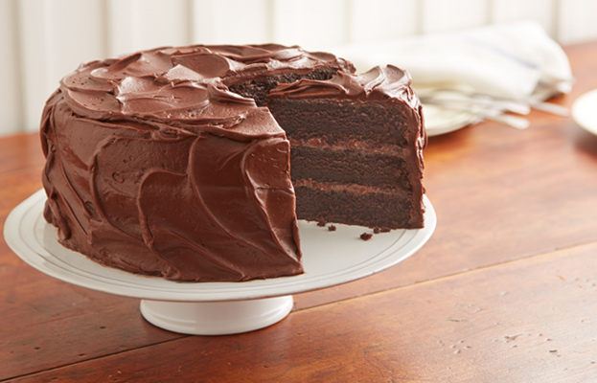
1 ¾ cups flour
¾ cup Hershey’s Cocoa powder
1 ½ teaspoons baking powder
1 ½ teaspoons baking soda
1 teaspoon salt
2 eggs
1 cup milk
½ cup vegetable oil
2 teaspoons vanilla extract
1 cup boiling water

Directions:
1. Preheat oven to 350°F. Grease and flour two 9-inch round baking pans.

2. Stir together sugar, flour, cocoa powder, baking powder, baking soda, and salt in a large bowl. Add eggs, milk, oil, and vanilla; beat on medium speed of mixer for 2 minutes. Stir in boiling water (the batter will be thin). Pour the batter into the prepared pans.

3. Bake for 30 to 35 minutes or until wooden toothpick inserted in center comes out clean. Cool in pans for 10 minutes, then remove from pans to wire racks. Cool completely. Frost with “Perfectly Chocolate” Chocolate Frosting.

Note: Can be baked in a 13 x 9 rectangular pan, for 35 to 40 minutes. Can also be baked as cupcakes: fill cups 2/3 full with batter, and bake 22 to 25 minutes.

“Perfectly Chocolate” Chocolate Frosting
½ cup (1 stick) butter or margarine
2/3 cup Hershey’s Cocoa powder
3 cups powdered (confectioners’) sugar
1/3 cup milk
1 teaspoon vanilla extract

1. Melt butter. Stir in cocoa powder. (I whisk it smooth.) Alternately add powdered sugar and milk, beating to spreading consistency. (You can add small amounts of additional milk or powdered sugar, as needed for frosting consistency.) Stir in vanilla extract. Makes about 2 cups of frosting.

This is some majorly chocolate cake! Yum! ~ Jennifer Keith

